CRSTRA Challenge Days 2018
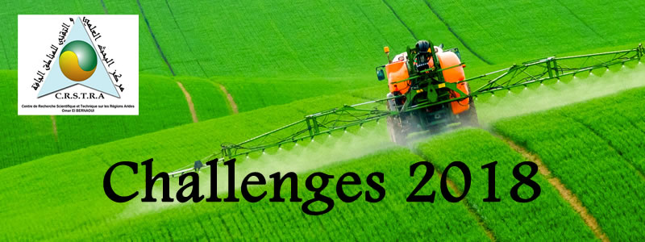

Theme:
N°:

Product Name :
Photo | Name :  Family name :  Position :  Birth :  Educational level (University/school/other) :  Adresse :  E-mail adresse :  Personel Details :
Illustration of the Product and/or Product schema (with high resolution) :

Objective and utility of the Product :
Relevance and novelty:
Application Domains and potential users:
In what framework was this Product?

Partners or Co-authors (with affiliation):
State of the project progress (« reached steps ; remaining steps) :

Description and details about the Product:

NB: Send by e-mail and / or send a CD containing the file and a presentation (animated preferably) of the product and the attached informations.

Mail :bouchahm.nora@crstra.dz / Adress :Centre de Recherche Scientifique et Technique des régions arides CRSTRA, BP 1682Biskra 07000, Algérie.

